How to install the Sweco SSD user profile

In the same folder that contains these instructions you will find a file named Sweco STRU profile v.xxxxxxxx
(xxxxxxxx = date of latest update)

Import user profile
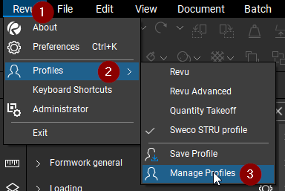 | 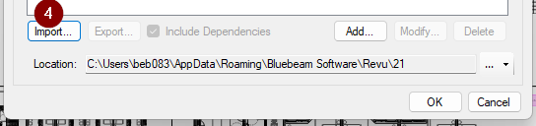

5. Select the downloaded .bpx user profile file from download location and click [OK]

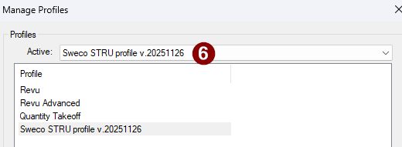

Now the following should be imported:
- User settings and layout of interface and tools that are not in the toolsets
- SSD toolsets
- Custom SSD linestyles

What is not imported:
- PDF templates: Files to be manually copied and pasted into templates folder:
C:\Users\ BEBxxx\AppData\Roaming\Bluebeam Software\Revu\21\Templates
  - Bluebeam toolchest building template – this is what all tools in the toolsets are made up of. It also includes some clarifications on tools and general rules for standardisation.
  - A few blank PDF’s with Sweco logo and a basic border (for random sketches/documents)
- Custom colour pallet settings (see DDG0010 Best Practises on how to set them up)
- Stamps: Stamps are special PDFs that should be pasted into your stamps folder:
C:\ProgramData\Bluebeam Software\Bluebeam Revu\21\Stamps

